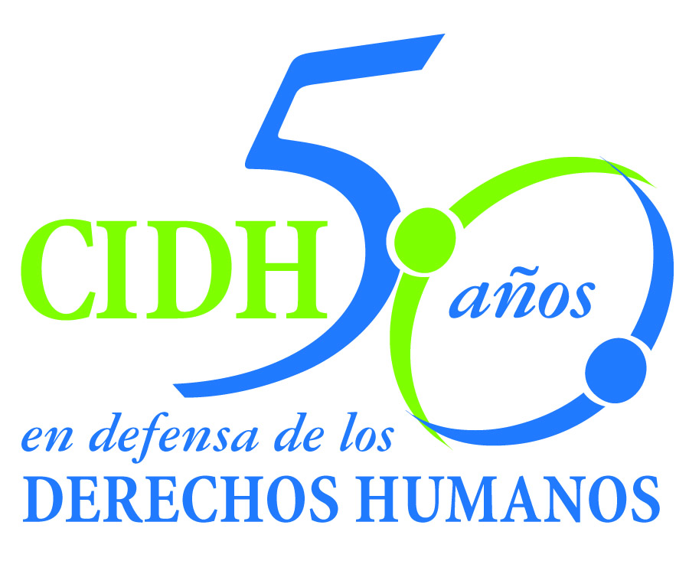INTER - AMERICAN COMMISSION ON HUMAN RIGHTS
COMISION INTERAMERICANA DE DERECHOS HUMANOS
COMISSÃO INTERAMERICANA DE DIREITOS HUMANOS
COMMISSION INTERAMÉRICAINE DES DROITS DE L'HOMME

ORGANIZACIÓN DE LOS ESTADOS AMERICANOS
WASHINGTON, D.C. 2 0 0 0 6 EEUU

July 10, 2012

Ref.: Case No. 12.606
Hermanos Landaeta Mejías y otros
Venezuela

Mr. Secretary:

I am pleased to address you on behalf of the Inter-American Commission on Human Rights in order to file Case No. 12.606 Landaeta Mejías Brothers et. al. vs. The Bolivarian State of Venezuela (hereinafter “the State”, “the Venezuelan State” or “Venezuela”) before the jurisdiction of the Honorable Inter-American Court of Human Rights, regarding the extrajudicial execution of both brothers Landaeta Mejías, Igmar Alexander and Eduardo José, 18 and 17 years old respectively, by forces of the Corp of Public Order and Security of the Aragua State. After threats and harassment against Igmar Alexander, he was extrajudicially executed on November 17, 1996;while a half months later - on December 30, 1996 - his brother, the child Eduardo José, was illegally and arbitrarily deprived of freedom, and the following day, during a supposed transfer, he was extrajudicially executed. These facts are framed in a context of extrajudicial executions in Venezuela, with special emphasis on the State of Aragua. The death of both brothers remains unpunished. In the case of Igmar Alexander, the criminal proceedings against the polices culminated with a dismissal, while in the case of Eduardo José, after 16 years of his death, the criminal trial Is still ongoing.

The State ratified the American Convention on Human Rights on August 9, 1977, and accepted the contentious jurisdiction of the Court on June 24, 1981.

The Commission has designated Commissioner Felipe González as its delegate Likewise, Elizabeth Abi-Mershed, Deputy Executive Secretary and Silvia Serrano Guzmán, attorney of the Executive Secretariat of the IACHR, will serve as legal advisors.

Pablo Saavedra Alessandri, Secretario
Inter-American Court on Human Rights
Apartado 6906-1000
San José, Costa Rica

In accordance with Article 35 of the Rules of Procedure of the Inter-American Court, the Commission is enclosing a copy of Report 56/12, prepared in compliance with Article 50 of the American Convention, as well as a copy of the entire file before the Inter-American Commission (Appendix I), and the annexes used in drafting Report 56/12 (Annexes). Said report was notified to the Venezuelan State by means of communication of April 10, 2012, granting it a period of two months to report on the implementation of the recommendations. The State of Venezuela has no answered to this requirement.

The Commission submits the instant case to the jurisdiction of the Inter-American Court due to the need to obtain justice for the victims and the lack of detailed and substantial information about State’s compliance with the recommendations.

The Commission submits to the Inter-American Court all the facts and violations of Human Rights stated in the Report on the Merits 58/12 and request that the Inter-American Court declare that the State of Argentina is responsible for:

- Violation of the rights to life and humane treatment enshrined in Articles 4 and 5 of the American Convention taken in conjunction with Article 1(1) of that instrument, to the detriment of Igmar Alexander Landaeta Mejías.
- Violation of the rights to life, humane treatment, personal liberty, and special protection due to children enshrined in Articles 4, 5, 7, and 19 of the American Convention taken in conjunction with Article 1(1) of that instrument, to the detriment of Eduardo José Landaeta Mejías.
- Violation of the rights to humane treatment, a fair trial, and judicial protection recognized at Articles 5, 8, and 25 of the American Convention taken in conjunction with Article 1(1) of that instrument, to the detriment of María Magdalena Mejías (mother), Ignacio Landaeta Muñoz (father), Victoria Eneri y Leydis Rossimar, (sisters), Francy Yelut Parra Guzmán (Alexander Landaeta Mejías' life partner), and Johanyelis Alejandra Parra (Igmar Alexander Landaeta Mejías' daughter).

Based on the foregoing conclusions, the Commission recommends that the Venezuelan State:

1. Conduct a complete, impartial, effective, and timely investigation of the human rights violations described in this report, in order to establish and impose punishment for the intellectual and material responsibility for the facts described.

2. These investigations must be conducted in such a way as to establish the links between each of the events covered in this report, as well as between those events and the more general context of violence and extrajudicial executions committed by the regional police.

3. Provide appropriate administrative, disciplinary, and criminal measures to address the actions and omissions of the State officials who contributed to justice denied and impunity surrounding the facts in this case.

4. Make adequate reparations for the human rights violations related in this report in both material and moral terms.

5. Provide mechanisms to prevent repetition, including: i) training programs on international human rights standards in general, and with respect to children and adolescents, directed to the Aragua State Police; ii) measures to ensure effective accountability in the criminal, disciplinary, and administrative sphere, in cases of alleged abuse of power by State agents responsible for public security; and iii) legislative, administrative, and other types of measures for investigating with due diligence and in accordance with relevant international standards the need for and proportionality of the lethal use of force by police officers, to ensure the existence of effective protocols so that adequate control and accountability mechanisms can be implemented in response to the actions of such officers.

Additionally, the Commission considers that the case deals with issues of inter-American public order.

First of all, the facts of the present case are part of a broader context of extrajudicial executions in Venezuela. The Commission has closely monitored this situation through different mechanisms. In particular, the Commission has addressed this problem since its report on the Situation of Human Rights in Venezuela of 2003. It also referred to this problem in its annual reports of 2004, 2005, 2006, 2007 and 2008, as well as in its recent report on Democracy and Human Rights in Venezuela of 2009. The Commission considers to be necessary to include in the analysis of the present case, an especial consideration to the characteristics of this serious context in Venezuela, in the terms described in the merits' report.

In addition to developing its jurisprudence on extrajudicial executions, this case also will allow the Court to study in depth the rights of the adolescents, especially the special measurements of protection that must be adopted from the moment itself which a adolescent go into state custody after a deprivation of freedom, to protect their personal safety from a situation of double vulnerability like the existing one in this case. In this regards, the Court will be able to analyze in a qualified way some of the implications of the guarantees contemplated in the American Convention, developing standards that will impact in the state obligations in this matter.

Additionally, and in accordance with article 35.1 f) of the Rules of Procedures, the Commission offers the following expert declarations in connection with the inter-American public interest issues related to this case:

- Expert whose name shall be informed promptly, who will testify on the state obligations to address general contexts of extrajudicial executions, from a holistic perspective that includes both the act of security officials directly involved, and the research and institutional response that must be given to address the different elements that favor the existence and permanence of problems of this nature. The expert will also make references to the non-repetition measures considered appropriate in situations such as the present case.
- Camaño Diego, who will declare on the state obligations regarding personal freedom when it comes to adolescents. Specifically, the expert will analyze the special obligations of the different part of Article 7 of the Convention applicable to this case, when it comes to teenagers immediately after the initial arrest.

The curricula vitae of the experts proposed by the Inter-American Commission are attached to the Merits Report 58/12.

The Commission notifies that the organization that represents the victims in the procedure before the Inter-American Court is the Centro por la Justicia y el Derecho Internacional y la Comisión de Derechos Humanos, de Justicia y Paz del Estado Aragua. The contact information is:

Centro por la Justicia y el Derecho Internacional (CEJIL)
XXXXXXXXXXXXXXXXXXX

Luis Manuel Aguilera (Comisión de Derechos Humanos, de Justicia y Paz del Estado Aragua)
XXXXXXXXXXXXXXXXXXXX

Please allow me to greet you and express my appreciation.

Signed in the original

Elizabeth Abi-Mershed
Deputy Executive Secretary

Enclosure

