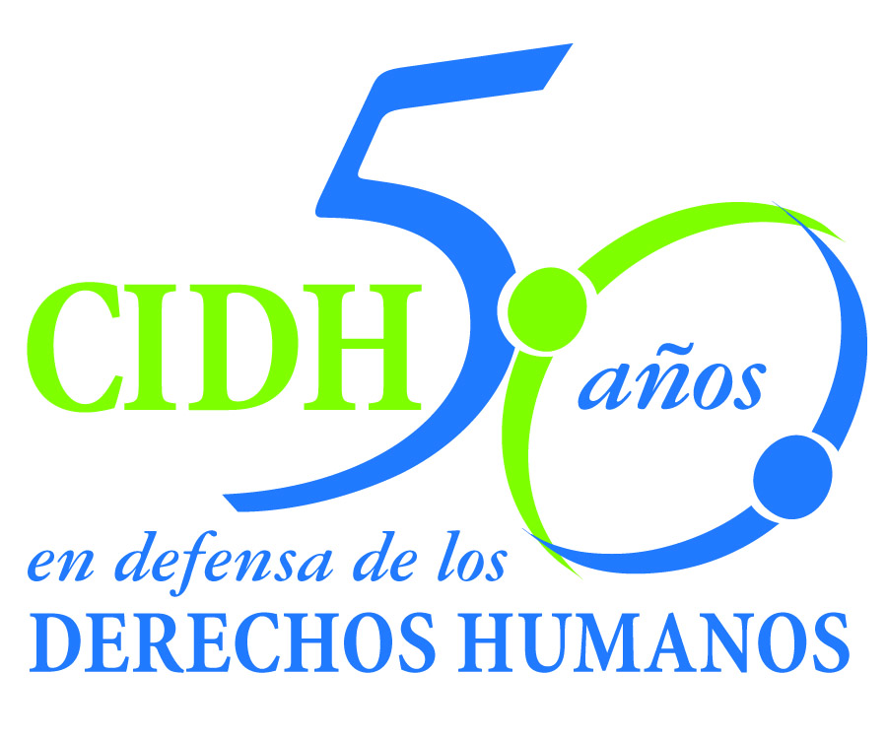INTER - AMERICAN COMMISSION ON HUMAN RIGHTS
COMISION INTERAMERICANA DE DERECHOS HUMANOS
COMISSÃO INTERAMERICANA DE DIREITOS HUMANOS
COMMISSION INTERAMÉRICAINE DES DROITS DE L'HOMME

ORGANIZACIÓN DE LOS ESTADOS AMERICANOS
WASHINGTON, D.C. 2 0 0 0 6 EEUU

June 10 2012

Ref.: Case No. 11.845
Jeremías Osorio Rivera y otros
Perú

Mr. Secretary:

I am pleased to address you on behalf of the Inter-American Commission on Human Rights in order to file Case No. 11.845, Jeremías Osorio Rivera et al v. the Republic of Peru (hereinafter “the State”, “the Peruvian State” or “Peru”) before the jurisdiction of the Inter-American Court of Human Rights. The case refers to the forced disappearance of Jeremías Osorio Rivera, who was detained by a Peruvian Army patrol on April 28, 1991, in the province of Cajatambo, department of Lima, without his whereabouts having been determined and without the persons responsible having been sanctioned to date. Mr. Osorio Rivera was detained by members of the Counter-Subversive Base of Cajatambo in a context of armed conflict, in which forced disappearance was used systematically by members of the State’s security forces. The IACHR also concluded that Jeremías Osorio Rivera was the target of deliberate acts of torture during his transfer by Army personnel on April 30, 1991 and that those members of the military concealed the information on the victim’s real whereabouts and then released false information.

Although the victim’s family members lodged a complaint against the commander of the patrol that detained him, Juan Carlos Tello Delgado, and participated actively in the criminal proceedings instituted as of May 1991, the case was referred to the military jurisdiction and dismissed in February 1996. After the restoration of democracy and the repeal of the Amnesty Laws that impeded an investigation into the crimes committed by agents of the Peruvian State in the context of the so-called “struggle against terrorism,” the investigations into the disappearance of Jeremías Osorio were reopened and are currently before the Supreme Court of Justice. The Commission concluded that more than 20 years after the victim’s forced disappearance and with the entire truth of the incident still not known, the domestic criminal proceedings have not offered an effective resource for determining the fate of the victim or for ensuring the rights of access to justice and to the truth through the investigation and punishment of those responsible.

Mr.
Pablo Saavedra Alessandri, Secretary
Inter-American Court of Human Rights
P.O. Box 6906-1000
San José, Costa Rica
Enclosure

The State ratified the American Convention on Human Rights on July 12, 1978, and accepted the contentious jurisdiction of the Court on January 21, 1981. In that regard, the facts debated in the case fall within the temporal jurisdiction of the Court. In addition, Peru deposited the instrument of ratification of the Inter-American Convention on Forced Disappearance of Persons (IACFDP) on August 30, 2001. Although the detention of Jeremías Osorio Rivera occurred on April 28, 1991, the case-law of the inter-American system establishes that the effects of a forced disappearance are continuing, thus the obligations contained in the IACFDP subsist until such time as the whereabouts of the victim are determined, sanctions are meted out, and reparation is made.

The Commission has designated Commissioner José de Jesús Orozco, and Executive Secretary Santiago A. Canton, as its delegates. Likewise, Elizabeth Abi-Mershed, Deputy Executive Secretary; Tatiana Gos and Daniel Cerqueira, attorneys of the Executive Secretariat of the IACHR, have been designated to serve as legal advisors.

In accordance with Article 35 of the Rules of Procedure of the Inter-American Court, the Commission is enclosing with this communication a copy of Report 140/11 prepared in compliance with Article 50 of the American Convention, as well as a copy of the entire file before the Inter-American Commission (Appendix 1) and the annexes used in the preparation of Report 140/11 (Annexes).

The Commission adopted Merits Report No. 140/11 on October 31, 2011, and transmitted it to the State on November 10, 2011; the State was given two months to report on the measures adopted to carry out the respective recommendations. On December 10, 2011, the petitioners presented a communication in which they state their reasons to justify their request for the case to be referred to the jurisdiction of the Inter-American Court. On January 11, 2012, the State presented a report its first report. On February 10, 2012 the State requested a two months extension and waived the right to allege that deadline before the Court. That same day the IACHR notified the State the granting of the extension. On March 21, 2012, the State presented its second report on compliance and requested a two months extension and waived the right to allege that deadline to the Court, in order to have more time to comply with the recommendations set out by the IACHR. On April 10, the IACHR notified the State the granting of the extension. On May 24, 2012 the State presented its third report on compliance and requested a third extension. However, taking into account the position of the petitioners and that the information provided by the State in three opportunities does not reveal substantial progress in complying with the recommendations set out, the Commission decided not to grant the extension requested and to submit the case to the jurisdiction of the Inter-American Court due to the need to obtain justice for the victims.

In particular, as regards recommendations 1 and 2, related to determining the whereabouts of the victim, investigation, and punishment of the persons responsible for his forced disappearance, the Commission notes that the State merely reported that “at this time the criminal proceeding against the accused Juan Carlos Tello Delgado is going forward in the domestic jurisdiction for the crime against humanity – forced disappearance – to the detriment of Jeremías Osorio Rivera. This proceeding is before the Supreme Court of Justice, and the IACHR is aware of that fact.” In addition, the petitioners informed that “the motion has been declare admissible, but it is still pending the merits phase, after which the case will be elevated to the Supreme Court of Justice”. The Commission observes that, to date, there is no information as regards the results of the motion presented and that Peru did not clarify how long the criminal proceeding under way against the only member of the military indicted, Juan Carlos Tello Delgado, could last nor indicated what measures it has been taking to investigate all the persons responsible for the victim’s forced disappearance. The State did not present information with respect to the actions undertaken to determine the whereabouts of the victim.

With respect to recommendation 3, related to reparation for the victim’s next-of-kin, the Commission notes that the State described the procedures and mechanisms of collective and individual reparations provided for in the National Reparations Plan. It stated that Law 28592 regulates that plan, and created the Single Registry of Victims, which includes the persons whose rights were impaired during the period of political violence in Peru from 1980 to 2000. It argued that on October 30, 2006 the Ombudsman granted a Forced Dissapearance Hearing certificate to Mr. Jeremías Osorio Rivera and that he “has already been officially recognized by the Peruvian State as a victim and recognized as such by the Council of Reparations of Peru in its session of August 13, 2008.” It added that “the widow and daughters of Mr. Osorio Rivera may have access […] to the integral reparations programs such as education, health care, insertion in the labor market, as well as direct economic benefits.” Nonetheless, it did not report on a likely date for carrying out the collective or individual measures of reparation to the benefit of Mr. Osorio’s common-law wife and daughters. The Commission observes that although the seven brothers and sisters and mother of Jeremías Osorio Rivera were considered victims by the IACHR in Report No. 140/11, they have not been included in the Single Registry of Victims regulated by Law 28592 nor the State has presented information about possible reparation on their behalf.

Regarding recommendation 4, related to legislative actions, protocols for the prevention and investigation of cases of forced disappearance, and other measures of non-repetition, including adaptation of the criminal definition of forced disappearance by the legislature, the State described various academic activities and training courses for judges and prosecutors on the investigation of serious human rights violations. It also told of several training courses held by the Ministry of Defense for different levels of the Armed Forces. It indicated that those courses are carried out by the Center for Humanitarian Law and Human Rights of the Armed Forces under an agreement with the International Committee of the Red Cross, universities, and non-governmental organizations specialized in human rights and international humanitarian law. In terms of adapting the criminal law definition of forced disappearance, Peru reported that “on November 21, 2011, the Speaker of the Congress of the Republic communicated with the then-director of the Vice-Ministerial Office requesting the terms and guidelines of a preliminary draft legislative proposal to amend Article 320 of the Criminal Code of Peru to bring it into line with the requirements of the American Convention.” The Commission notes that the State did not present current information or information specifically related to the case. Also the State did not explain how those norms and its actual implementation make it possible to regard the defects that gave rise to the facts of the instant case as overcome. The State did not present specific information about any other measures aimed at amending Article 320 of its Criminal Code.
Concerning recommendation 5, related to public acknowledgement of international responsibility, the Commission observes that the State did not present any information.
In addition, in its last report of May 24, 2012, the State indicated that on May 23, a meeting with the wife and four children of the victim was held in order to evaluate the possibility of reaching a friendly settlement in this case. However, this process has been hampered by the brothers of the victim and their legal representative, who conditioned the agreement to the progress of the criminal proceedings, without taking into account other measures adopted with respect to the other recommendations. However, in its communication dated June 5, 2012 the petitioners indicated that the State never proposed the possibility to reach a friendly settlement. The Commission notes that the State did not indicate the terms of a possible agreement, beyond the measures of justice.
In consequence, Commission submits this case to the jurisdiction of the Inter-American Court in view of to the need to obtain justice for the victims, the nature and gravity of the violations found, and the failure of the State to carry out the recommendations.

The Commission notes that this case will allow the Court to continue consolidating its case law in relation to the use of forced disappearance in contexts of armed conflict, and reiterates the need to bring the domestic legislation into line with the provisions of the American Convention, in relation to the criminalization of the forced disappearance of persons in Peru.

The Inter-American Commission is submitting to the jurisdiction of the Court the full facts and human rights violations as set out in merits report 140/11 and asks the Court to adjudge and declare the international responsibility of the State of Peru for the:

violations of the rights enshrined in Articles 3, 4, 5.1, 5.2, 7, 8.1, and 25.1 of the American Convention, in conjunction with Articles 1.1 and 2 thereof. It also established that the State is responsible for violating Articles I and III of the IACFDP, all with respect to Jeremías Osorio Rivera. With reference to the relatives of the victim, IACHR concluded that the State is responsible for the violation of Articles 5.1, 8.1, and 25 of the American Convention, in conjunction with Articles 1.1 and 2 thereof, with respect to Juana Rivera Lozano (mother), Alejandrina, Elena, Porfirio, Adelaida, Silvia, Mario and Efraín Osorio Rivera (brothers and sisters), Santa Fe Gaytán Calderón (common-law wife), Edith Laritza, Neyda Rocío, Vanesa and Jeremías (children).

Consequently, the Commission is asking the Inter-American Court to order the following reparations:

- Conduct a complete, impartial, and effective investigation into the whereabouts of Jeremías Osorio Rivera and, should it be discovered that the victim is not alive, take the steps necessary for his remains to be returned to his family.

- Pursue the domestic procedures related to the human rights violations established in this report and discharge the criminal proceedings for the crime of forced disappearance with respect to Jeremías Osorio Rivera currently underway, in an impartial and effective fashion and within a reasonable time, in order to fully clear up the incident, identify all the guilty, and impose the corresponding penalties.

- Provide adequate redress for the human rights violations established in this report, covering both the material and moral aspects and including fair compensation, the establishment and dissemination of the historical truth of the incident, the necessary measures aimed to keep alive the disappeared victim’s memory, and the implementation of a suitable program of psychosocial care for his next-of-kin.

- Take the necessary steps to prevent similar events from occurring in the future, in accordance with the duty of prevention and the obligation of guaranteeing the fundamental rights recognized in the American Convention. In particular, implement permanent programs on human rights and international humanitarian law at the training schools of the Armed Forces.

- Organize an act of public recognition of its international responsibility and extend a public apology for the violations established in this report.

Finally, as regards the issues of inter-American public interest that the case raises, the Commission notes that this case constitutes an opportunity for the Court to develop its case law and to establish standards in relation to the duty to conduct investigations in cases of forced disappearance – mindful of the difficulties associated with the passage of time – and the content of the obligations of due diligence, access to justice, and guarantee of the right to the truth, so as to carry out measures of justice as a form of present-day reparation.

Likewise, given that these issues have a significant impact on inter-American public order, pursuant to Article 35.1.f) of the Rules of Procedure of the Inter-American Court, the Commission would like to offer the following expert’s statement:

1. Almudena Bernabeu, who will develop the content of the state obligation to act with due diligence in investigating cases of forced disappearance, as a present-day measure of reparation. The expert will also analyze the adequate measures for continuing or reinitiating investigations aimed at determining the whereabouts of the victim and the identification of persons who may be responsible, mindful of the passage of long periods of time and other difficulties obtaining evidence. Finally, reference will be made to international standards that make it possible to evaluate the sufficiency of the measures implemented by the States in light of the obligation to guarantee access to justice and the right to the truth by clearing up the facts and determining the corresponding responsibilities.

The curriculum vitae of the expert proposed by the Inter-American Commission will be included in the annexes to merits report 140/11.

Finally, the name of the organization that served as petitioner in the case before the Commission and its particulars are as follows:

Dr. Miguel Jugo Viera
Xxxxxxxxxxxx
Xxxxxxxxxxxxxxx
xxxxxxxxxxxxxxxx

Please accept renewed assurances of my highest regards.

Signed in the original
Elizabeth Abi-Mershed
Deputy Executive Secretary

