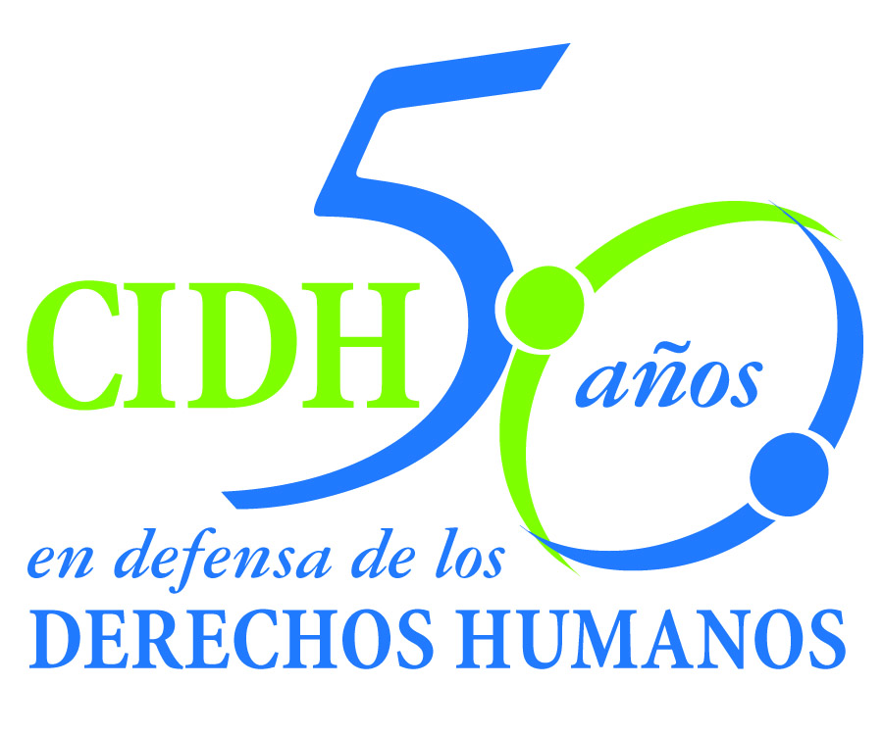INTER - AMERICAN COMMISSION ON HUMAN RIGHTS
COMISION INTERAMERICANA DE DERECHOS HUMANOS
COMISSÃO INTERAMERICANA DE DIREITOS HUMANOS
COMMISSION INTERAMÉRICAINE DES DROITS DE L'HOMME

ORGANIZACIÓN DE LOS ESTADOS AMERICANOS
WASHINGTON, D.C. 2 0 0 0 6 EEUU

January 4, 2012

Ref.: Case No. 11.769 - A
J.
Perú

Mr. Secretary:

I am pleased to address you on behalf of the Inter-American Commission on Human Rights in order to file Case No. 11.769-A, J. v. the State of Peru (hereinafter “the State,” “the Peruvian State” or “Peru”), before the jurisdiction of the Honorable Inter-American Court of Human Rights., relating to the illegal and arbitrary detention of J. and the home searches conducted on April 13, 1992 by State agents, who committed acts of torture and cruel, inhumane and degrading treatment, including rape of the victim. Following those acts, Ms. J was taken to the National Counter-Terrorism Directorate (DIRCOTE) and deprived of her liberty in that place for 17 days, without judicial oversight and in inhuman conditions. Furthermore, the case relates to a series of violations of due process and of the principle of legality and non-retroactivity in connection with the criminal proceedings against the victim on account of alleged crimes of terrorism when Decree Law 25475 was in force. Ms. J. was acquitted in June 1993, after which she left Peru. On December 27, 1993, the anonymous ("faceless") Supreme Court of Justice annulled the acquittal without explanation of its reasons for doing so and ordered a retrial. To this day, proceedings against Ms. J. remain pending in Peru, with an international warrant for her arrest.

The State of Peru ratified the American Convention on Human Rights (hereinafter “the American Convention” or “the ACHR”) on July 28, 1978 and accepted the contentious jurisdiction of the Court on January 21, 1981. Likewise, the State of Peru also ratified the Inter-American Convention to Prevent and Punish Torture on March 28, 1991, and the Inter-American Convention on the Prevention, Punishment and Eradication of Violence Against Women “Convention Of Belém do Pará" on June 4,1996.

The Commission has designated Commissioner José de Jesús Orozco Henríquez and Executive Secretary of the IACHR, Santiago A. Canton, as its delegates. Likewise, Elizabeth Abi-Mershed, Deputy Executive Secretary, and Silvia Serrano Guzmán, attorneys at the Executive Secretariat of the IACHR will serve as legal advisors.

Mr.
Pablo Saavedra Alessandri, Secretary
Inter-American Court of Human Rights
Apartado 6906-1000
San José, Costa Rica

Attachments

In accordance with Article 35 of the Rules of Procedure of the Inter-American Court, the Commission is enclosing with this communication a copy of Report No. 76/11 prepared in accordance with Article 50 of the American Convention, as well as a copy of the entire file before the Inter-American Commission (Appendix I) and the annexes used in drafting Report 76/11. Said merits report was notified to the Peruvian State by means of communication of August 4, 2011, granting it a two-month term to report on the implementation of the recommendations. The Peruvian State requested an extension from the Inter-American Commission in order to report on compliance with the recommendations. The Commission granted a two-month extension to the State and requested that it present a report by no later than December 20, 2011. The Commission received the State's report on time. On December 28, 2011, the State submitted a supplementary report.

The Commission submits the instant case to the jurisdiction of the Inter-American Court due to the State’s failure to comply with the recommendations and the consequent need to obtain justice for the victims. During the period granted to the State to report on implementation of the recommendations, Peru questioned the conclusions of the report on the merits and considered that the recommendations to make full reparation to Ms. J. and to investigate the acts that violated her human rights were impossible to carry out given that J. was not in Peru.

According to the State, the only measure of reparation is the new trial with guarantees of due process, and for that it would be necessary for Ms. J. to appear in person. In that regard, the Commission notes that the case involves a series of violations that vary in kind and thus require different forms of reparation that are not restricted to a trial with due guarantees. The case involves, for instance, violations of the right to humane treatment, which by their very nature and because of their effects requires compensation, moral reparation, and rehabilitation measures.

As for the State's view that it is impossible to investigate the facts of the case, the Commission recalls, as stated in the report on the merits, that the State was apprised of Ms. J.'s allegations of torture on several occasions, including the initial petition to the IACHR, in spite of which it abstained from starting an investigation. This omission is ongoing given the failure to implement this recommendation. Furthermore, the State did not explain why Ms. J.'s presence is essential to throw light on the deeds that violated her human rights. In any event, that is no excuse for the State not carrying out its duty ex officio.

At the same time, the Commission notes that the State did not report on measures adopted after the report on the merits to implement the remaining recommendations, which were to complete the process of adjustments to domestic laws and to refrain from exercising the punitive power of the State in cases in which the problems persist that generated the violations of the American Convention, including the use of evidence obtained illegally or arbitrarily. On this matter, the Commission notes that in its supplementary report the State particularly emphasized the need to investigate alleged crimes of terrorism and considered it unacceptable to waive the exercise of its punitive power. The Commission wishes to clarify that implementation of the recommendations made does not entail a waiver such as that referred to by the State. Rather, it would ensure that the domestic legal system is in line with Peru's obligations under the regional system.

The Inter-American Commission submits to the jurisdiction of the Court the entire set of facts and human rights violations set forth in the report on the merits No. 76/11 and requests that the Court find and declare the State of Peru internationally liable for violating the rights to humane treatment, personal liberty, a fair trial, freedom from ex post facto laws and from retroactivity, privacy, and respect for her honor, dignity and private life, and judicial protection established in Articles 5, 7, 8, 9, 11 and 25 of the American Convention, in conjunction with the obligations established in Articles 1.1 and 2 of that instrument, to the detriment of Ms. J. Furthermore, the Commission requests that the Court find and declare Peru responsible for violation of the rights established in Articles 1, 6, and 8 of the Inter-American Convention to Prevent and Punish Torture and in Article 7 of the Convention to Prevent, Punish, and Eradicate Violence against Women, to the detriment of Ms. J.

Consequently, the Commission asks the Inter-American Court to order the following:

- Order full reparations for Ms. Mónica Feria Tinta for the human rights violations declared in this report. The reparations should include pecuniary and non-pecuniary damages. If the victim so desires, order the necessary measures for rehabilitation of her physical and mental health.

- Conduct an impartial and effective investigation, within a reasonable period of time, to shed full light on the violations of the American Convention, identify the intellectual and material authors and impose the appropriate penalties.

- Order the administrative, disciplinary or criminal proceedings to address the actions or omissions by state officials that had the effect of denying justice to the victim and allowing those responsible for the violations established to go unpunished.

- Complete the process of amending the provisions of Decree Law 25475 that are still in force and that this report found to be incompatible with the American Convention

- Cease and desist from any exercise of the State’s punitive authority against Mónica Feria Tinta that perpetuates the same procedural flaws that vitiated the legal proceedings conducted in 1992 and 1993 and that led to violations of the American Convention. Specifically, the State must take steps to ensure that no legal case is prosecuted against Ms. Feria Tinta that is based on evidence obtained by illegal and arbitrary means, as described in this report on the merits.

In addition to the need to see justice done for the victim, the IACHR points out that the instant case raises issues of inter-American ordre public.

Specifically, given that the victim was raped by State agents at the time of her arrest and nothing has been done to investigate the incident, the case affords an opportunity for the Inter-American Court to develop its analysis of different forms of sexual assault as acts of torture; the obligations to investigate such cases and to prosecute and punish the perpetrators; and the reparation measures appropriate in these types of violations.

In addition, the Court will have an opportunity to consolidate its jurisprudence on the incompatibility of trying crimes of terrorism under Decree law 25475 with greater precision as to violations of due process, including the various limitations on the exercise of the right to defense, the violation of the presumption of innocence, and the retroactive application of the grounds adduced in that Decree.

Since these matters affect in a significant manner the inter-American public order of human rights, pursuant to Article 35.1.f of the Rules of Procedure of the Inter-American Court, the Commission wishes to offer declarations by the following experts:

- Sofía Macher Batanero, who will testify on the different forms of sexual violence and their characterization under international human rights law. The expert will refer to characteristics that are relevant for classifying some forms of sexual violence as acts of torture and she will address international obligations to investigate and punish those responsible in these kinds of cases. Finally, this expert will testify regarding the international standards to be borne in mind when determining reparation to be made for sexual violence.

- Stefan Trechsel, who will testify regarding international standards of due process in criminal cases that are relevant when it comes to analyzing restrictions to due process, such as the possibility of exercising the right of defense in the context of legal frameworks designed to prosecute and punish terrorism. The expert will provide guidelines for analyzing the compatibility of said restrictions with the American Convention.

The currícula vitae of the proposed experts will be included in the attachments to the report on the merits No. 76/11.

The Commission wishes to inform the Court that Ms. J. is representing herself in the instant case. The contact data that the Commission possesses are included in the confidentiality Attachment.

Finally, the Commission reports that, after being notified of the report on the merits, Ms. J submitted a writ listing family members affected by the violations against her. This information is available in the file of the case before the IACHR (Appendix I)

Signed in the original

Santiago A. Canton
Executive Secretary

The information regarding the decision to keep her identity confidential can be found in the Attachment to this communication.

