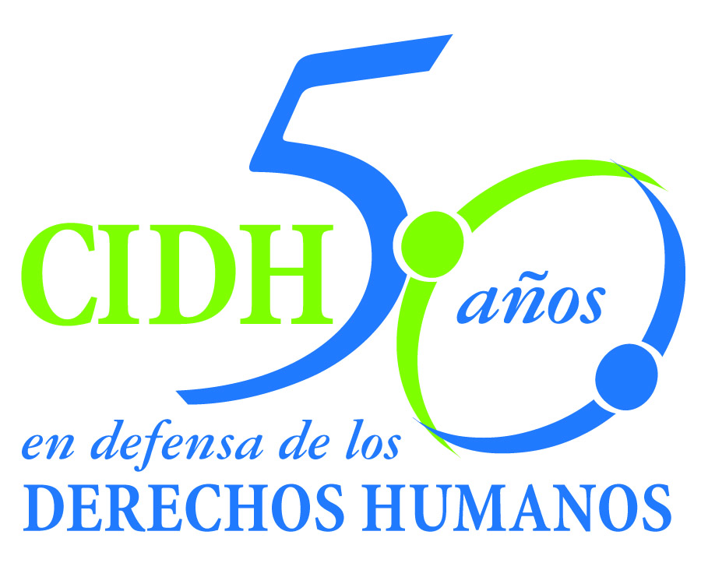INTER - AMERICAN COMMISSION ON HUMAN RIGHTS
COMISION INTERAMERICANA DE DERECHOS HUMANOS
COMISSÃO INTERAMERICANA DE DIREITOS HUMANOS
COMMISSION INTERAMÉRICAINE DES DROITS DE L'HOMME

ORGANIZACIÓN DE LOS ESTADOS AMERICANOS
WASHINGTON, D.C. 2 0 0 0 6 EEUU

March 8, 2011
Ref.: Case No. 10.720
The Massacres of El Mozote and Neighboring Locations
El Salvador

Mr. Secretary:

I am pleased to address you on behalf of the Inter-American Commission on Human Rights in order to file Case No. 10.720, The Massacres of El Mozote and Neighboring Locations v. the State of El Salvador (hereinafter “the State,” “the Salvadorian State” or “El Salvador”), before the jurisdiction of the Inter-American Court of Human Rights. The case concerns consecutive massacres committed between December 11 and 13, 1981 within a military operation by the Atlacatl Battalion, together with associated military units, in seven different locations in the north of the Department of Morazán. Thus, the indiscriminate attack against the civilian population commenced in the small village of El Mozote, continued in the Canton of La Joya, the townships of Ranchería, Los Toriles and Jocote Amarillo, and concluded in the Canton of Cerro Pando and the Cave of the Ortiz Hill (Cerro Ortiz.) As a result of these facts, about a thousand people lost their lives. While an investigation of these events was initiated, they remain unpunished after the dismissal of the case rendered on September 27, 1993, in the light of the General Amnesty Law for the Consolidation of Peace, which remains in effect in El Salvador. In later years, some exhumations were carried out but they did not cause the reactivation of the investigations, despite repeated requests to the relevant authorities.

The State ratified the American Convention on Human Rights on June 23, 1978, and accepted the contentious jurisdiction of the Court on June 6, 1995. In addition, the State ratified the Inter-American Convention to Prevent and Punish Torture and the Inter-American Convention to Prevent, Punish and Eradicate Violence against Women on December 5, 1994 and January 26, 1996, respectively.

Mr.
Pablo Saavedra Alessandri, Secretary
Inter-American Court of Human Rights
P.O. Box 6906-1000
San José, Costa Rica

Enclosures

The Commission has designated Commissioner Paulo Sérgio Pinheiro, and Executive Secretary of the IACHR, Santiago A. Canton, as its delegates. Likewise, Elizabeth Abi-Mershed, Deputy Executive Secretary, and Isabel Madariaga and Silvia Serrano Guzmán, attorneys at the Executive Secretariat of the IACHR will serve as legal advisors.

In accordance with Article 35 of the Rules of Procedure of the Inter-American Court, the Commission is enclosing with this communication a copy of Report 177/10 prepared in accordance with Article 50 of the American Convention, as well as three annexes related to the identification of the victims by the Commission until the time of the adoption of the above-mentioned report. The Commission is also enclosing a copy of the entire file before the Inter-American Commission (Appendix I) and the annexes used in drafting Report 177/10 (Annexes). Said merits report was notified to the El Salvadorian State by means of communication of November 22, 2010, granting it a two-month term to report on the implementation of the recommendations. When deciding on the merits of the case, the Inter-American Commission concluded that the State of El Salvador is internationally responsible for:

    - The violation of the rights to life, to humane treatment and to personal liberty enshrined in Articles 4, 5, and 7 of the American Convention in relation to article 1(1) thereof, to the detriment of the victims who were executed extrajudicially;

    - The violation of the special obligations with respect to children established in Article 19 of the American Convention, in relation to Article 1(1) thereof, to the detriment of the children who were executed extrajudicially;

    - The violation of the rights to humane treatment and privacy enshrined in Articles 5 and 11 of the American Convention, to the detriment of the women who were raped in the village of El Mozote;

    - The violation of the Right to property enshrined in Article 21 of the American Convention in relation to article 1(1) thereof, to the detriment of the murdered victims who were stripped of their property, as well as the survivors whose homes were destroyed or whose means of livelihood were stolen or eliminated;

    - The violation of the right to humane treatment enshrined in Article 5 of the American Convention in relation to article 1(1) thereof, to the detriment of the survivors and next-of-kin of the executed victims;

    - The violation of the right to freedom of movement and residence enshrined in Article 22 of the American Convention in relation to Article 1(1) thereof, to the detriment of the persons who were forcibly displaced; and

    - The violation of the rights to a fair trial and judicial protection enshrined in Articles 8 and 25 of the American Convention in relation with the obligations established in articles 1(1) and 2 thereof, with Articles 1, 6 and 8 of the Inter-American Convention to Prevent and Punish Torture, and with Article 7 of the Convention of Belém do Pará, to the detriment of the survivors and relatives of the executed victims.

With regard to the identification of the victims of these violations, Report 177/10 includes three separate annexes which consist of the list of: i) the victims extrajudicially executed; ii) the survivors and relatives of the executed victims; and iii) the victims forcibly displaced. In its merits report (paras. 203-214), the Inter-American Commission stated the criteria taken into account for the identification of the victims, in order not to exclude a priori the victim-condition of any person so identified as deceased in the massacres or as surviving next-of-kin, taking into account the exceptional characteristics of this case. However, the IACHR clarifies now that much of the data about name, age, sex or family ties are approximate and imprecise. In this case, the IACHR adopted “flexible criteria for the identification of the victims,” under the understanding that, as indicated in one of the recommendations of Report 177/10, it corresponds to the State of El Salvador to carry out the complete identification of the victims executed in the Massacres of El Mozote and neighboring locations, as well as the next-of-kin of the executed victims, within the framework of the proper investigation that it is required to perform.

Report 177/10 was notified to the State of El Salvador by means of communication of December 8, 2010, granting it a two-month term to inform on the implementation of the recommendations. To this date, the State has not replied to the request made by the Commission.

As a result, the Commission submits the instant case to the jurisdiction of the Inter-American Court due to the need to obtain justice and the State’s failure to comply with the recommendations.

Specifically, the Commission submits to the jurisdiction of the Court the State acts and omissions that occurred after June 6, 1995, the date of the acceptance of the Court’s jurisdiction by El Salvador. As indicated in Report 177/10, part of the set of facts that are within the temporal jurisdiction of the Court, includes: the validity of the General Amnesty Law for the Consolidation of Peace; the omission in the reopening of the investigations; the absence of continued and sustained efforts to exhume a greater number of mortal remains; the lack of judicial follow-up of the exhumations carried out and the information obtained in the framework of the same; the absence of a response to the requests for the reopening of the investigations; the effects of the massacres and their impunity on the surviving next-of-kin of the victims; the lack of reparation in favor of them; and the situation of displacement of some victims. The afore-mentioned, without prejudice that the State of El Salvador might accept the jurisdiction of the Court to study the entire case, in accordance with the terms of Article 62(2) of the American Convention.

The Commission requests that the Court orders the following measures of reparation:

  - Make adequate reparations for the violations of human rights, both in their material and their moral aspect, including the establishment and dissemination of the historic truth of the events, suitable commemoration of the victims who died, and implementation of an appropriate program of psycho-social care for the surviving relatives;

  - Establish a mechanism to ensure that the victims executed in the massacres at El Mozote and neighboring locations are identified as fully as possible and take the necessary steps to pursue the continuity of the exhumation, identification and return of the remains of those victims in accordance with the desires of their families. This mechanism must also facilitate the complete identification of the relatives of the executed victims, so that they can be eligible for the reparations called for in the previous recommendation;

  - Render ineffective the General Amnesty Law for the Consolidation of Peace as it prevents the investigation, trial and sanction of those responsible for human rights violations and the rights of victims to truth, justice, and reparation. Also, any other de jure or de facto obstacles, such as judicial or investigative practices, must be eliminated;

  - Regardless of the above, the State should proceed immediately to investigate in an impartial, effective manner and within a reasonable time with the purpose to establishing the facts in a complete form, identify the intellectual and material authors and impose the sanctions that correspond. In the immediate fulfillment of this obligation, the Salvadorian authorities cannot invoke the validity of the General Amnesty Law for the Consolidation of Peace;

  - Take the corresponding administrative, disciplinary or criminal actions to sanction the actions or omissions of the State officials who contributed to the denial of justice and the impunity in which are the facts of the case or who participated in actions to hinder the processes designed to identify and punish those responsible; and

    - Take the measures necessary to prevent similar events in the future, in observance of the duty to respect and guarantee human rights recognized in the American Convention. In particular, implement permanent programs on Human Rights and International Humanitarian Law in the Armed Forces Training Schools.

The violations that occurred in this case affect the inter-American public interest and continue to date due to the generalized impunity of the acts.

The IACHR concluded in Report 177/10 that the Massacres of El Mozote and neighboring locations were committed precisely during the cruelest period of the wrongly denominated “counterinsurgency” operations performed by the Salvadorian army, in a massive way, against civilians during the armed conflict, and in open disregard of the most basic principles underlying the International Law of Human Rights and International Humanitarian Law.

These massacres were committed indiscriminately and with extreme cruelty, to a regrettable balance of approximately 1,000 people, including an alarming number of children. The systematic and generalized nature of those actions, the purpose of which was to sow terror among the population, has been recognized on several occasions, and it may be concluded that the massacres constituted one of the most aberrant manifestations of crimes against humanity committed at that time by the Salvadoran military.

However, due to the force of the General Amnesty Law for the Consolidation of Peace, as well as repeated omissions by the Salvadoran State, these serious events remain unpunished. To date, the massacres have not been judicially clarified, nor have any sanctions been established, even when a significant number of perpetrators have been identified by various sources, including the report of the Truth Commission, ‘From Madness to Hope’ (De la Locura a la Esperanza.)

As the IACHR stated in its merits report, it is an urgent duty of the State of El Salvador to settle the historical debt with the memory of the victims, the surviving next-of-kin, and with society at large, who after almost 30 years of the occurrence of the facts, have not been able to know the truth and to obtain justice through the punishment of those responsible for these crimes against humanity.

As a result of the above, the IACHR’s offers the following expert declarations on the mentioned aspects that concern the inter-American public interest, and in accordance with Article 35(1)( f) of the Rules of Procedure of the Inter-American Court:

- Expert whose name will be informed soon, who will refer to the context of armed conflict in El Salvador, especially in the time to which the facts of the case refer. The testimony will refer to the human rights violations occurring during said time, including the massive and indiscriminated attacks against the civilian population and the modus operandi followed under the “tierra arrasada” operations.

- Michael Reed Hurtado will testify about the General Amnesty Law for the Consolidation of Peace, its background, scope and effect as a factor in the impunity for crimes against humanity committed during the conflict by the Salvadoran Armed Forces. Also, the testimony will refer to attempts at interpretation by the Supreme Court of Justice, the effects of such interpretations, as well as the internal mechanisms to render ineffective the abovementioned law.

3. Tal Linda lleen Simmons who will testify about the internationally accepted parameters to be observed in the conduct of exhumations in cases such as this, as well as an analysis of the exhumations conducted internally in the light of these standards.

The curricula vitae of the experts proposed by the Inter-American Commission are attached.

The representatives of the victims in the filing before the Inter-American Court are the Office of the Legal Guardianship of the Archibishopric (Oficina de Tutela Legal del Arzobispado) and the Center for Justice and International Law (CEJIL). The Commission informs the Court that after the notification of Merits Report 177/10, the representatives provided some details about the list of victims and added the names of new victims. In accordance with what is stated in the present note about the flexible criteria of the identification of the victims, the Commission considers that the dimension and nature of the violations that occurred in this case, people added by the representatives should also be regarded as victims.

Finally, the Commission informs the Court that the information available about the representatives is:

Office of the Legal Guardianship of the Archibishopric of San Salvador
Tutela Legal del Arzobispado de San Salvador
Lic. María Julia Hernández
Archibishopric of San Salvador
XXXXXXXXXXXXXXXXXXXX
XXXXXXXXXXXXXXXX
XXXXXXXXX
San Salvador, El Salvador
XXXXXXXXXXXXXXX

CEJIL/MESOAMÉRICA
XXXXXXXXXXXXXXXX

Please accept renewed assurances of my highest regards.

Signed in the original

Elizabeth Abi-Mershed
Deputy Executive Secretary

